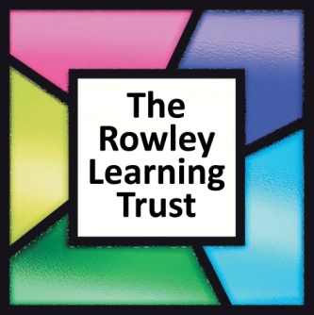
The Rowley Learning Trust
Annual General Meeting
Wednesday 2nd July 2025 at 2.45pm via Microsoft Teams

AGENDA
- Welcome
- Purpose of Meeting
- Apologies received
- Approval of minutes of AGM 01.07.24 (attached)
- Approval of Annual Report and Financial Statements 2024/25 (attached)
- Retirement and Appointment of Trustees (if any)
- Motions for discussion from Attendees
- Closing Statements

