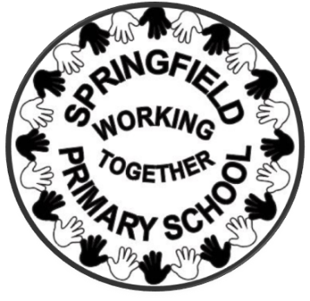
Springfield Primary School

HEAD TEACHER: Mrs Alison Bhardwaj BEd (Hons) NPQH
DEPUTY HEAD TEACHER: Mrs Claire Seddon
Dudley Road, Rowley Regis, West Midlands, B65 8JY
Tel: 0121 559 1333 Fax: 0121 508 6862
School website: www.springfield.sandwell.sch.uk

Wednesday 10th June

Dear Parents and Carers,

Changes to Free School Meal Eligibility from September 2026
We are writing to inform you of important national changes to Free School Meal (FSM) eligibility that will come into effect from September 2026.

The government has announced a significant expansion of the scheme, which means more families will become eligible for free school meals from the start of the 2026/27 academic year.

✅ What is changing?
From September 2026:
- All children in households receiving Universal Credit will be entitled to Free School Meals, regardless of household earnings.
- This replaces the current system, where families must have annual earnings below £7,400 to qualify.
- As a result, many more pupils are expected to become eligible.

⚠️ Important information about current entitlements
- The transitional protections that have been in place since 2018 will end at the end of the current academic year (July 2026).
- From September 2026, all families will need to meet the new eligibility criteria to continue receiving free school meals.
- Some families whose circumstances have changed may need to reapply or check eligibility.

🍽 Universal Infant Free School Meals
Please note:
- Children in Reception, Year 1 and Year 2 will continue to receive universal free school meals, regardless of family income.

📝 What you need to do
We strongly encourage all parents and carers to:
- Check your eligibility, even if you have not qualified before
- Apply or reapply for Free School Meals where appropriate
- Ensure your application is submitted before the start of the autumn term
Even if your child already receives free meals, you may still need to complete an application to ensure their entitlement continues.
Applying also helps the school receive additional funding (Pupil Premium), which supports teaching, resources and wider opportunities for pupils.

🔒 Your information and confidentiality
We understand that applying for free school meals can feel sensitive. Please be assured that all applications and personal information are treated in strict confidence. Only authorised staff and the local authority will process eligibility checks, and this information is not shared more widely within the school community.
Children receiving free school meals are not identified in any way, and all pupils are treated equally with respect and care.

💬 Why this matters
Free school meals can:
- Save families a significant amount each year
- Ensure children receive a healthy, balanced meal each day
- Support children’s learning, wellbeing and concentration in school

📞 Need help?
If you are unsure whether you qualify or would like support completing an application, please contact the school office. We are happy to help in confidence. https://my.sandwell.gov.uk/service/Free_school_meals

Yours sincerely,

Alison Bhardwaj
Headteacher

